**Lab Report**

Course Name : Electrical Circuits

Course Code : CSE209 LAB

Section No : 04

Experiment N : 02

Experiment name : Series-Parallel DC Circuit and Verification of Kirchhoff’s Laws.

**Submitted to**

Course instructor : Rashedul Amin Tuhin

Senior lecturer

Computer science and engineering

**Submitted by**

Name: Apurba Roy Ajay

Student’s ID : 2018-3-60-063

Department : Computer science and engineering

**Date of report submission : /09/2020**

**Objectives:**

1. To learn analysis of dc series-parallel circuit.
2. To verify Kirchhoff’s Voltage Law (KVL).
3. To verify Kirchhoff’s Current Law (KCL).

**Circuit Diagram:**

­­

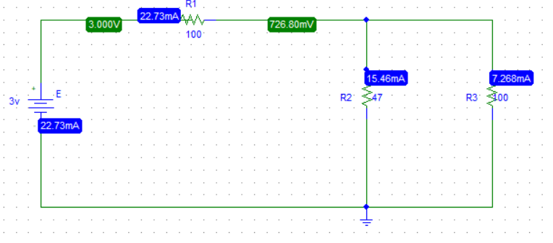g

**Experimental Datasheet:**

|  |  |  |  |  |  |  |  |
| --- | --- | --- | --- | --- | --- | --- | --- |
| Measured | Measured | Measured | Measured | Measured | Measured | Measured | Measured |
| Value of | Value of | Value of | Value of | Value of | Value of | Value of | Value of |
| *E* (V) | *V*1(V) | *V*2(V) | *V*3(V) | *I*1(mA) | *I*2(mA) | *I*3(mA) | Resistances |
|  |  |  |  |  |  |  | () |
|  |  |  |  |  |  |  | *R*1=100 |
| 3 | 3 | 0.7268 | 0.7268 | 22.73 | 15.46 | 7.268 | *R*2=47 |
|  |  |  |  |  |  |  | *R*3=100 |

**Answer(s) to the Post-Lab Report Question(s):**

1.



I3

I2

I1

V1

V3

V2

Compare this circuit , Kirchhoff’s law ,  
 E- V1- V2 =0  
From the circuit, R2 and R3 are in parallel. So, $\frac{1}{R_{q}}= \frac{1}{R_{2}}+ \frac{1}{R_{2}}=\frac{1}{47}+\frac{1}{100}$ $∴ R_{q}=31.97Ω$
   
 After Modify the circuit:  
 

Now, R1 and Rq are in series, so, R=100+31.97 =131.97 $Ω$

We know,

I= $\frac{V}{R}= \frac{3}{131.97} A= 22.73mA$.

We know series circuit is current same.

That means I= I1 = 22.73mA

V1 = I1R1= 22.73mA $×100Ω=2.273 V$

From the modify circuit ,  
 Vq = 22.73mA $×31.97Ω=0.727 V$

We know parallel circuit are voltage same,  
 Vq= V2= V3=0.727 V = 7.268mA

v1= 3 V I1=22.73mA

v2=­0.7268 V  I2=15.46 mA

v3= 0.7268 V I3= 7.268mA.

2. I got the calculate value of V1= 3 V, V2=­0.7268 V,V3= 0.7268 V, I1=22.73mA, I2=15.46 mA, I3= 7.268mA.

1. V2= V3=0.7268V(showed)
2. E= V1 + V2
3. I1= I2 + I3

**Conclusion:**

We connect this circuit using Pspice software.I think if we could do this same experiment in the lab, the measure value would change a little bit and most importantly we could learn how to connect the circuit for real life.